Experience Your Own Healing Power!

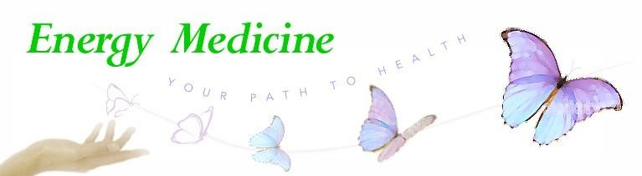

**Donna Eden’s Energy Medicine**

**Level 1: Fundamentals Training**

**_____________________________________________________**

* **New Classes Start May 15, 2025**
* **Level 1: Fundamentals will teach you the core techniques of Eden Energy Medicine (EEM) to help yourself, family, friends and/or integrate it into your practice.**
* **Have a life changing impact on your health and the health of your loved ones or clients.**
* **Learn how to work with the body’s electromagnetic and subtle energies to help the body activate its natural healing energies and improve resilience.**
* **Everybody is different and no one technique is ideal for everybody. Learn how to find, assess, and correct energy imbalances in multiple energy systems to tailor the corrections to each individual.**

**Course Details: Level 1: Fundamentals is a one-year program training in the foundational skills and methods of EEM. Four Extended Weekends over one year so you can fit the training into your schedule.**

**Small classes with lots of individual attention and hand-on practice! You’ll get the personalized instruction and support you need**

**There are no prerequisites to enroll. Each class has lecture, hands-on practice in a small group, and post class supervision.**

Registration/Information:

# For

**For More Information, Contact:**

**Marcia Rowland, Certified Advanced Eden Energy Medicine Practitioner (EEM-AP) and Authorized Teacher**

**Text and Phone: 952-334-3101 Email: EnergyMedicine-MN@comcast.net**

or Text: 952-334-3101. Email: EnergyMedicine-MN@comcast.net.